**STRUCTURES AND CLASSES**

**LAB # 10 & 11**



**Spring 2022**

**CSE102L Computer Programming Lab**

Submitted by: **Ali Asghar**

Registration No. : **21PWCSE2059**

Class Section: **C**

“On my honor, as student of University of Engineering and Technology, I have neither given nor received unauthorized assistance on this academic work.”

Student Signature: ______________

Submitted to:

**Engr. Abdullah Hamid**

July 4, 2022

Department of Computer Systems Engineering

University of Engineering and Technology, Peshawar

**Lab Objective(s)**

To understand pointer role in arrays and functions To learn about data structures and classes in C++

* To learn about data structures and classes in C++

**TASK # 1:**

**Title:**

A phone number such is (091) 767-8900 can be……………Display both numbers.

**CODE SCREENSHOTS:**

Here are the screenshots of the code.

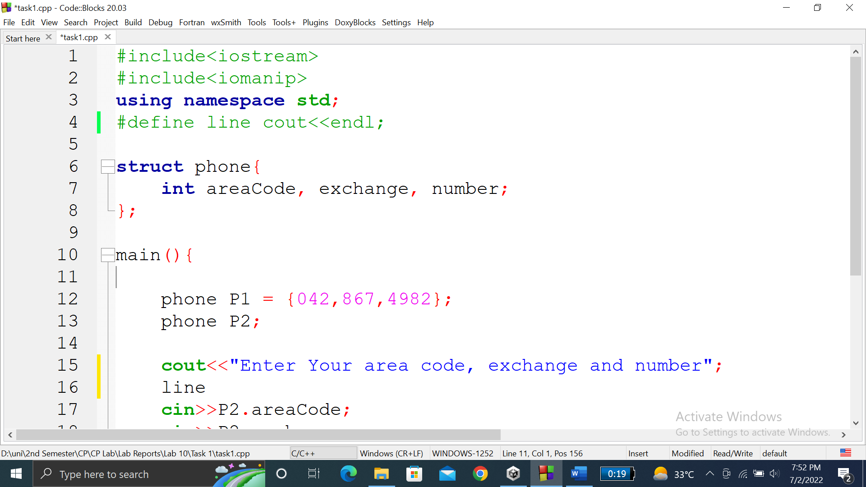

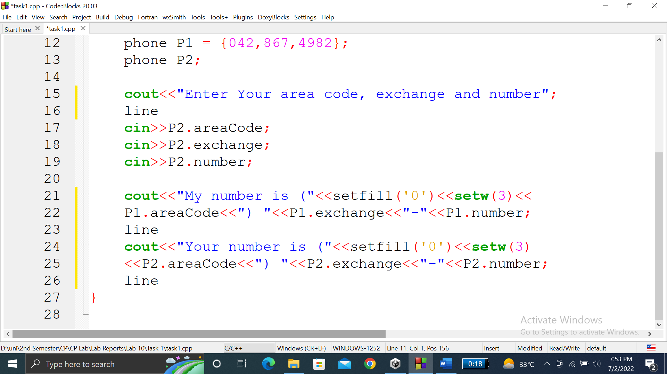

### **OUTPUT (COMPILATION, DEBUGGING & TESTING):**

Here is the screenshot of the output of above code.

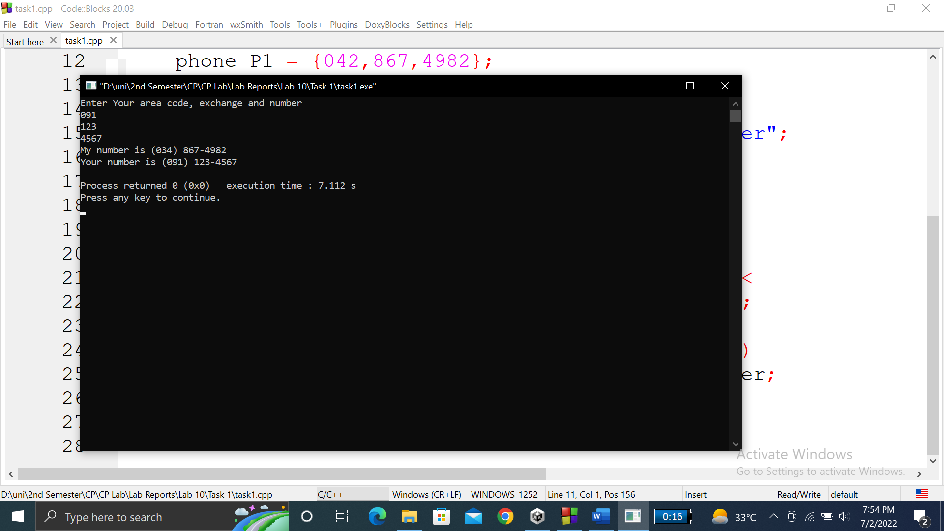

**TASK # 2:**

**Title:**

Write a C++ Program where you create a movie database…..……then display the move title and names.

**CODE SCREENSHOTS:**

Here is the screenshot of the code.

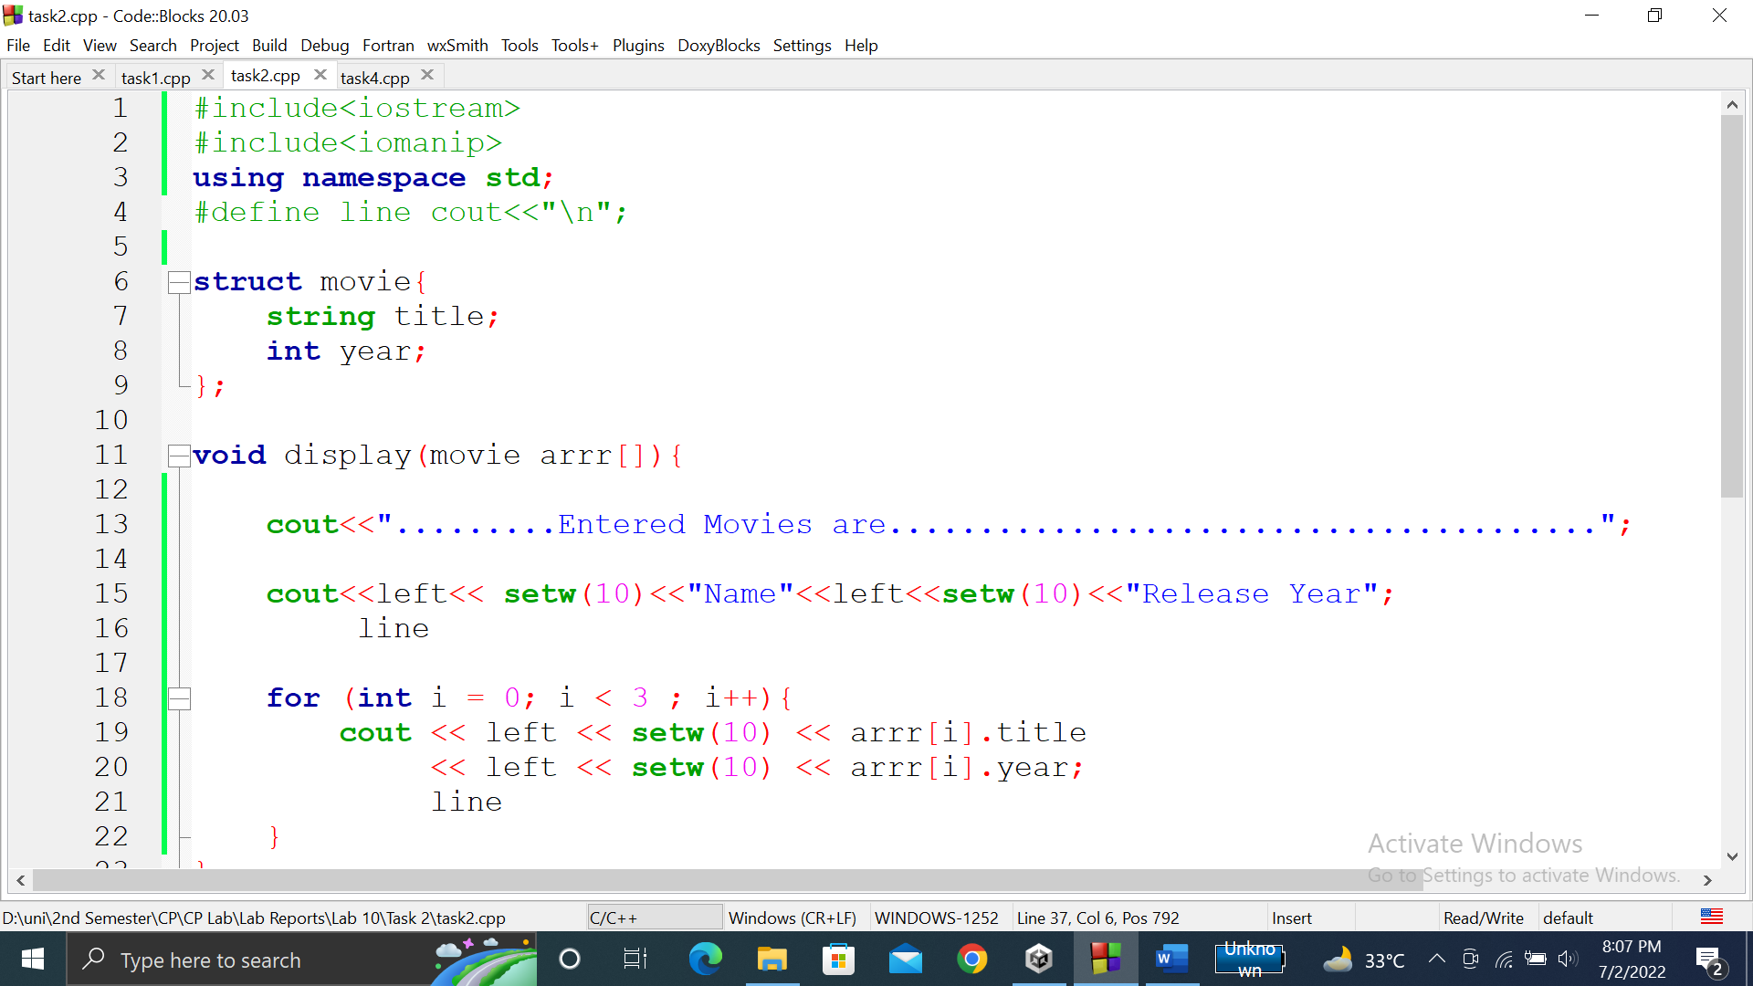

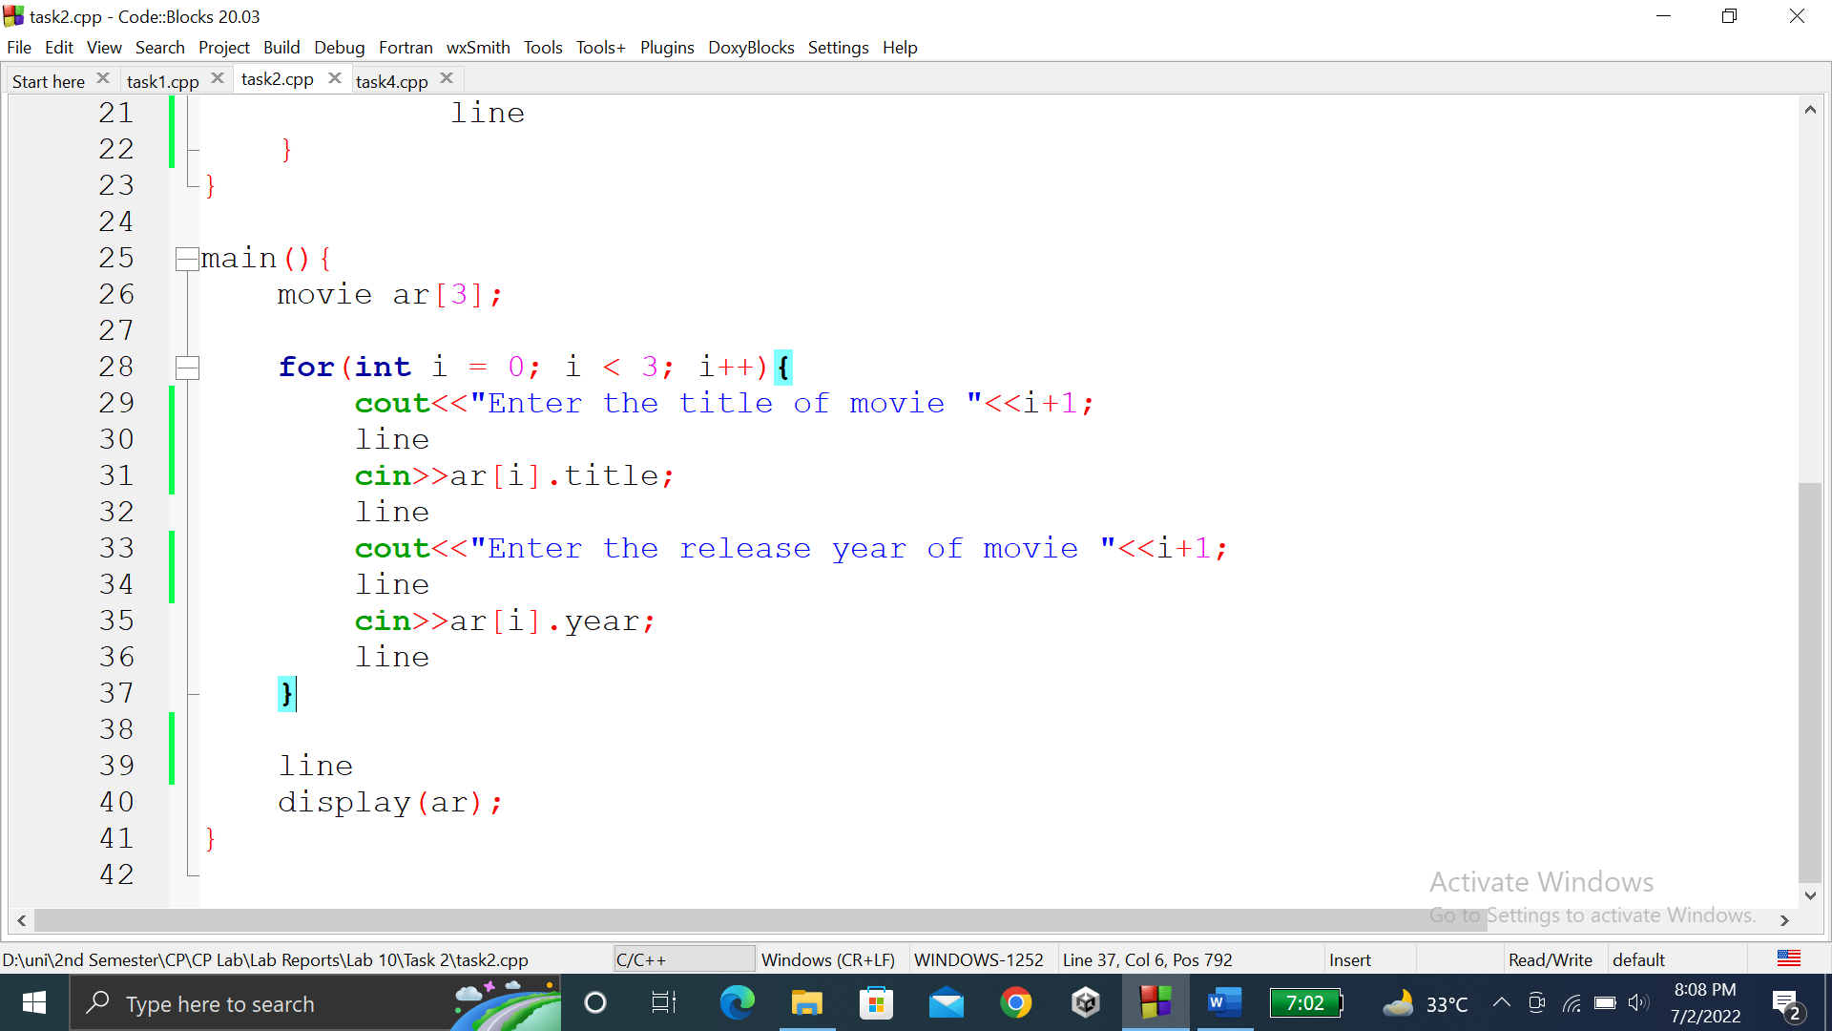

### **OUTPUT (COMPILATION, DEBUGGING & TESTING):**

Here are the screenshots of the output of above code.

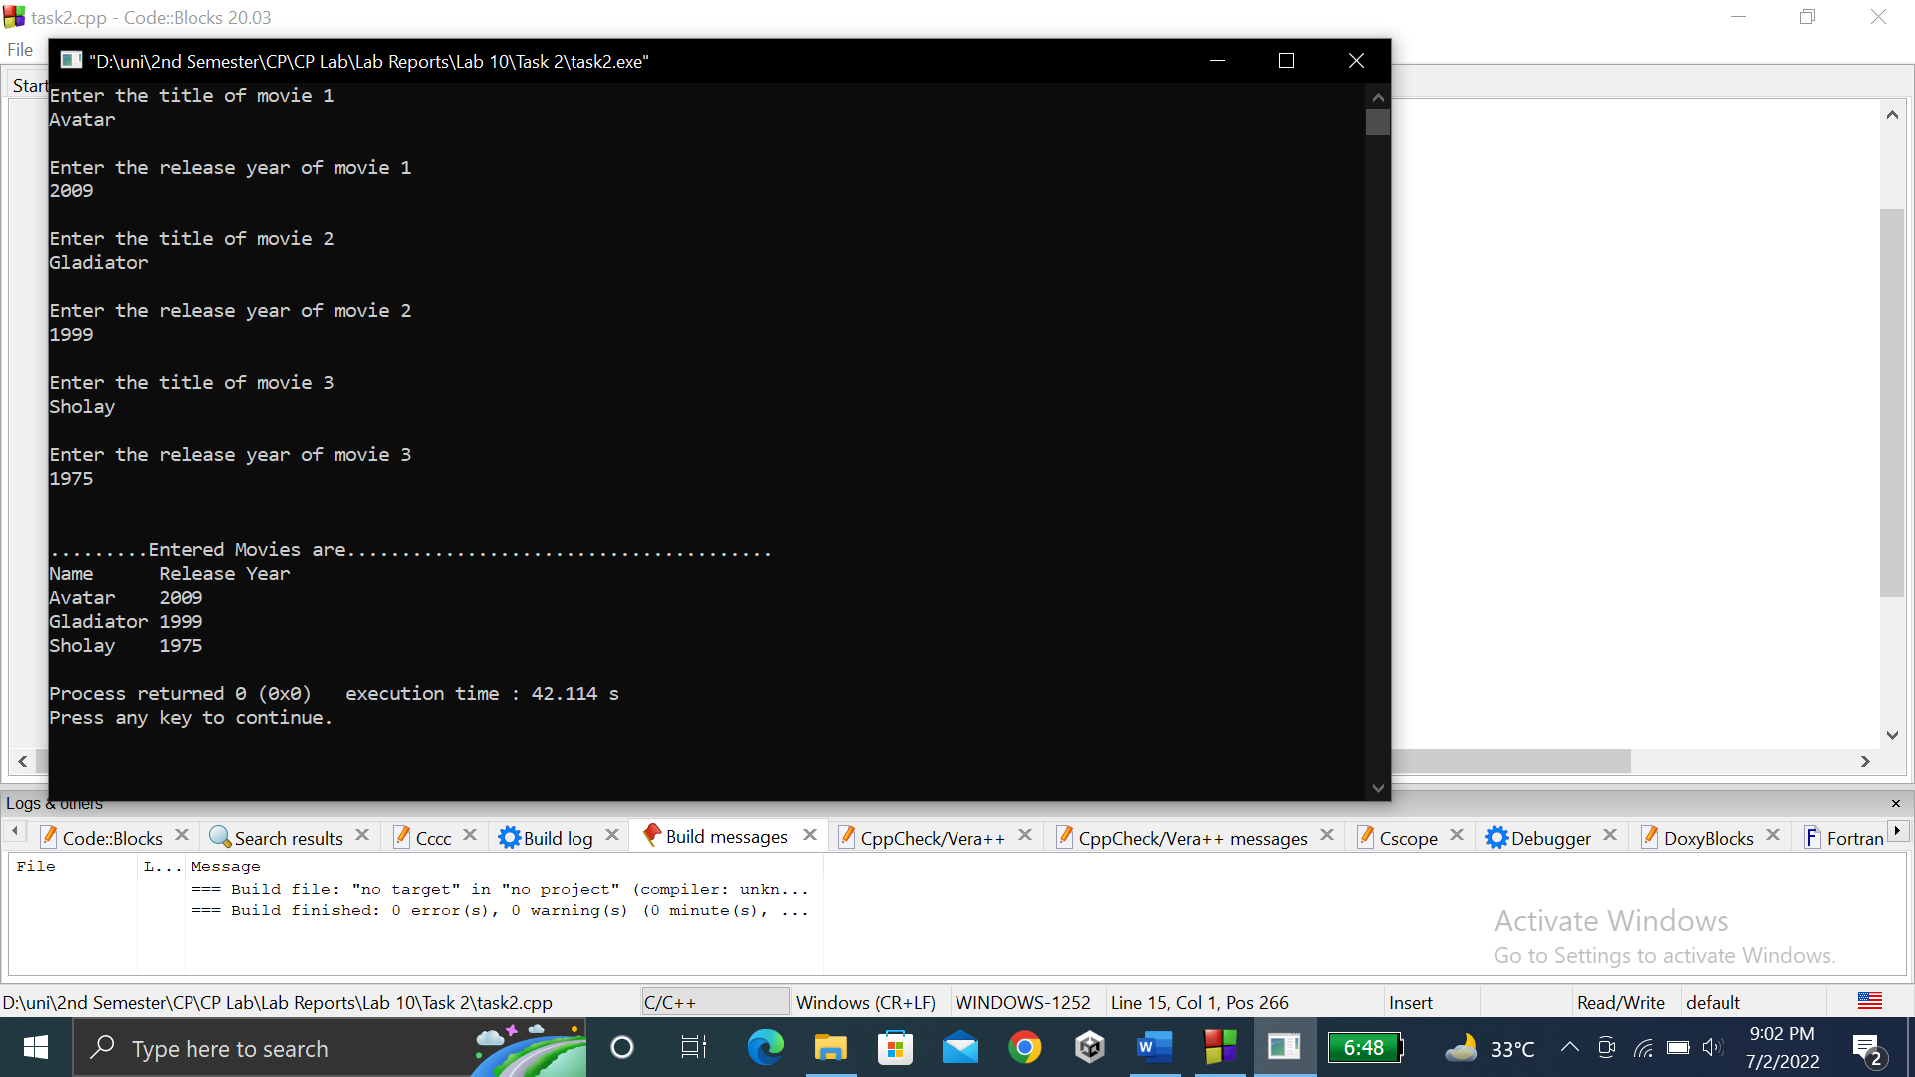

**TASK # 3:**

**Title:**

A point on a two-dimensional space has two……………entered height and width of the rectangle.

**CODE SCREENSHOTS:**

Here is the screenshot of the code.

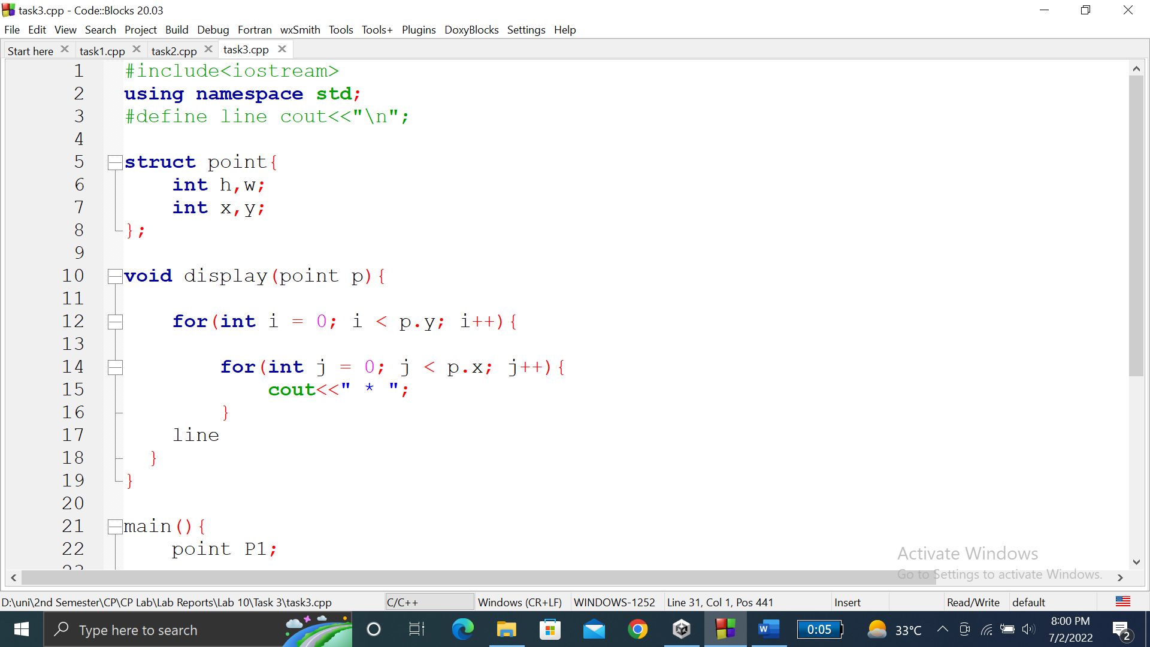

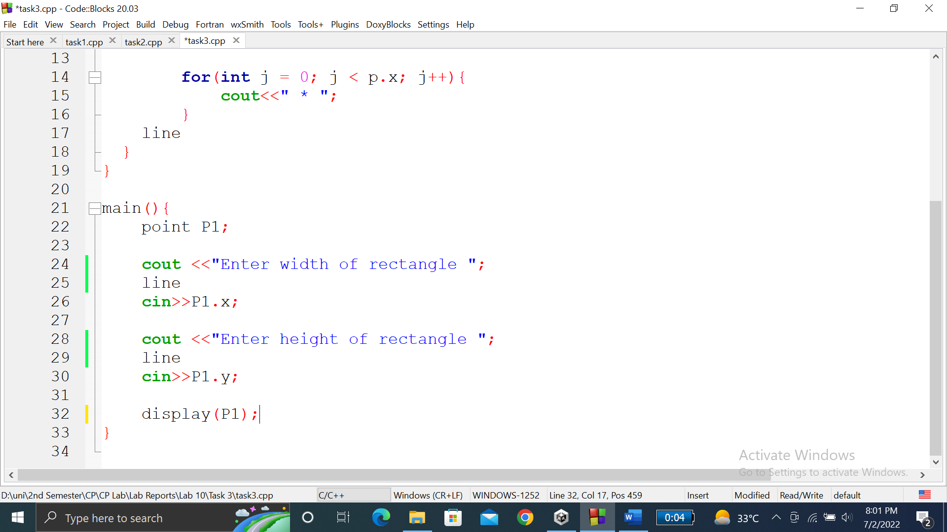

### **OUTPUT (COMPILATION, DEBUGGING & TESTING):**

Here is the screenshot of the output of above code.

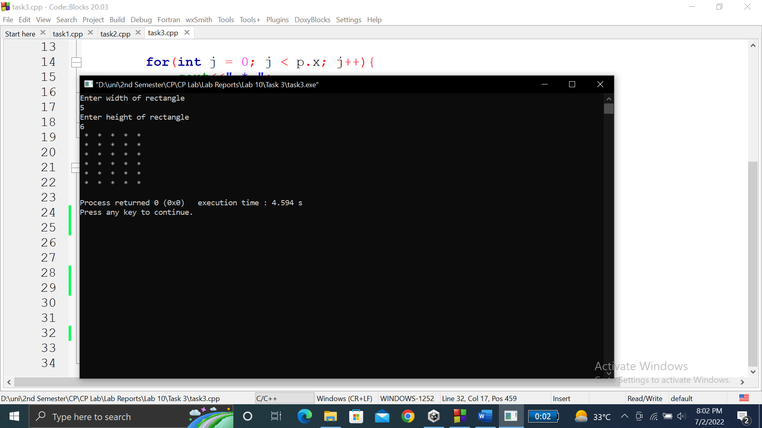

**TASK # 4:**

**Title:**

Write a program to develop student information system…………………….when asked to do so, via reg no.

**CODE SCREENSHOTS:**

Here is the screenshot of the code.

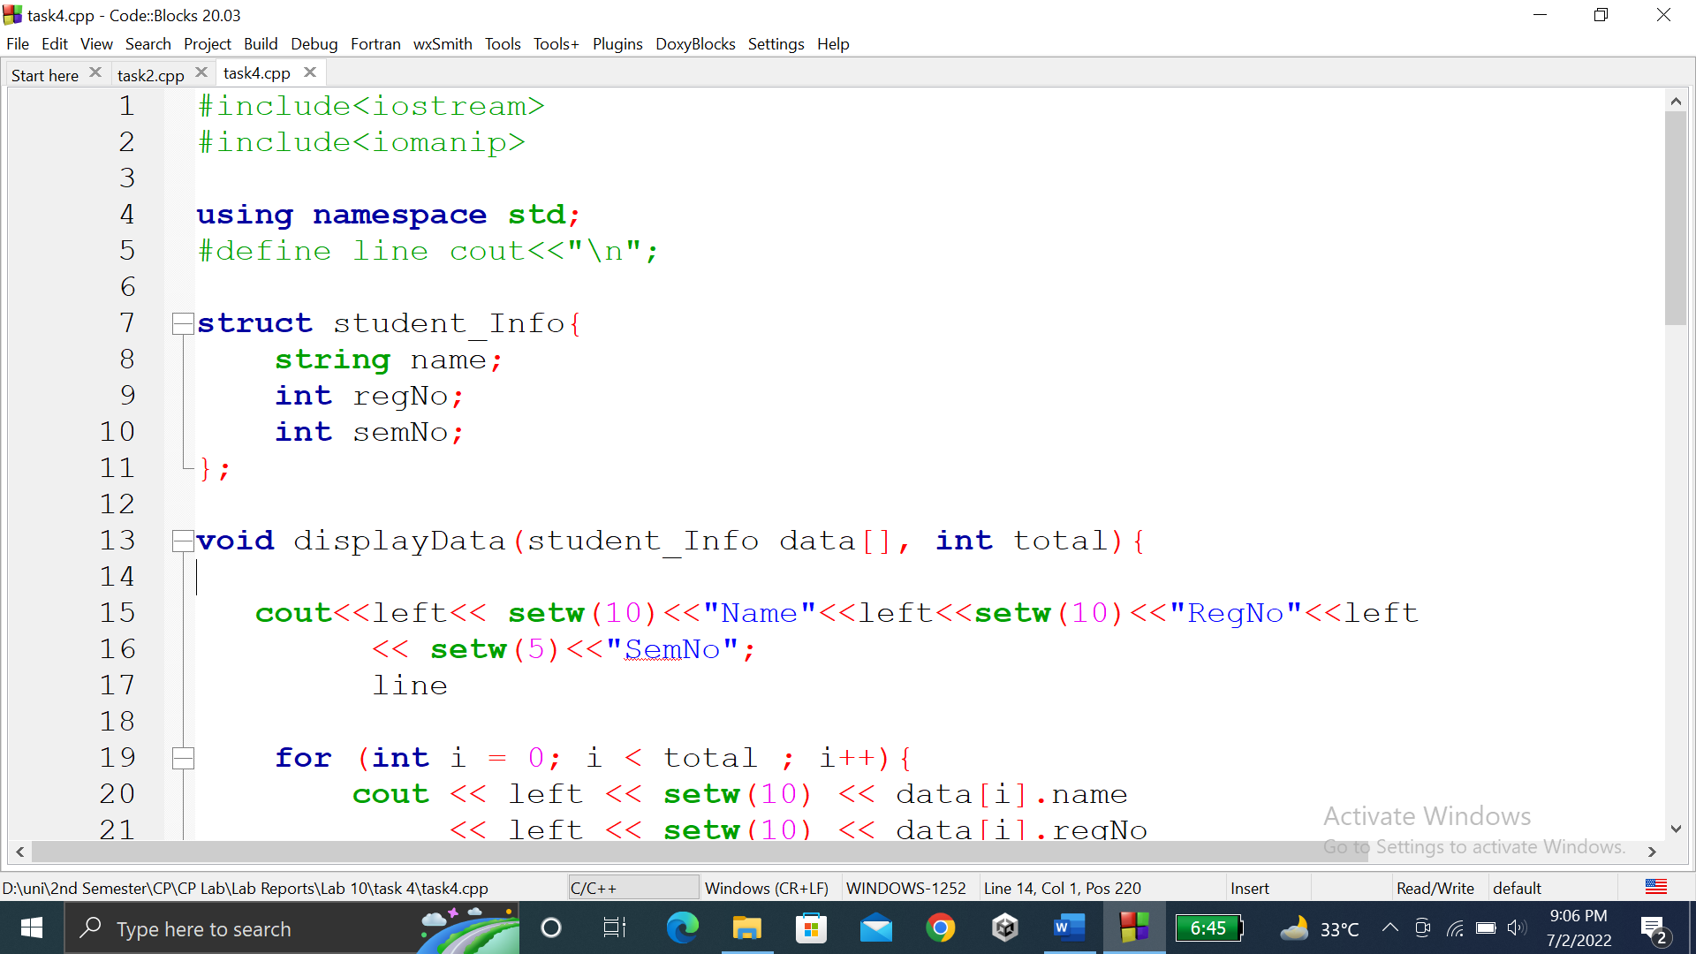

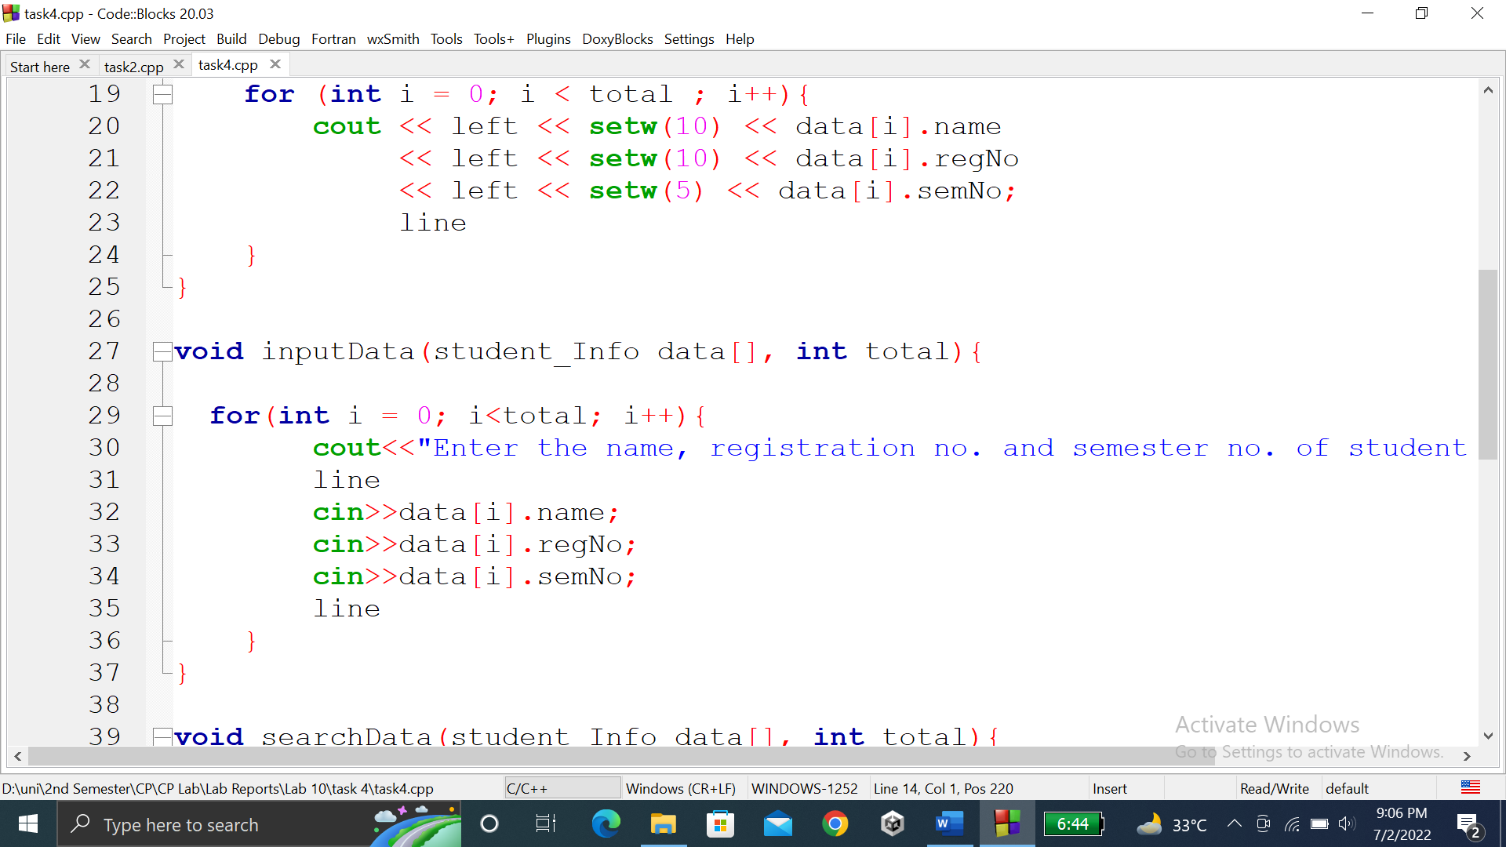

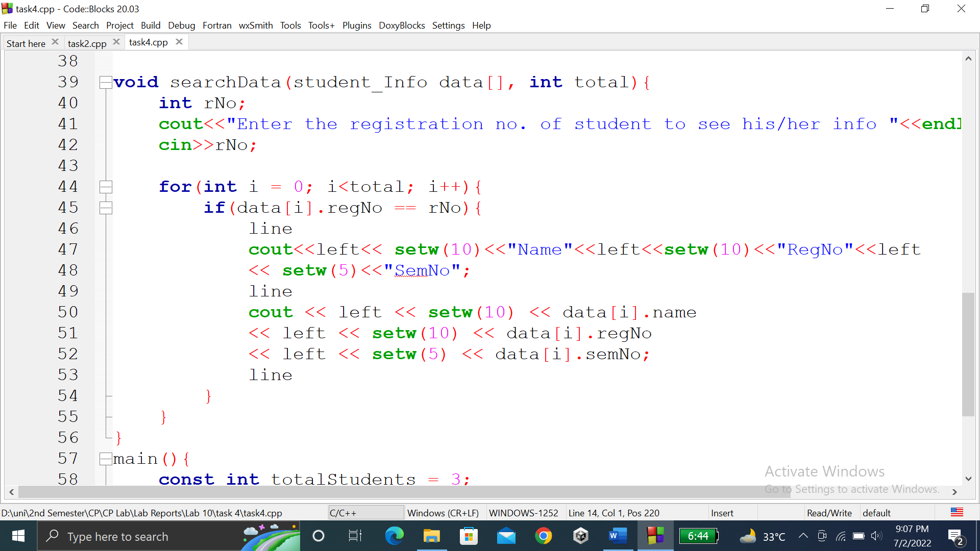

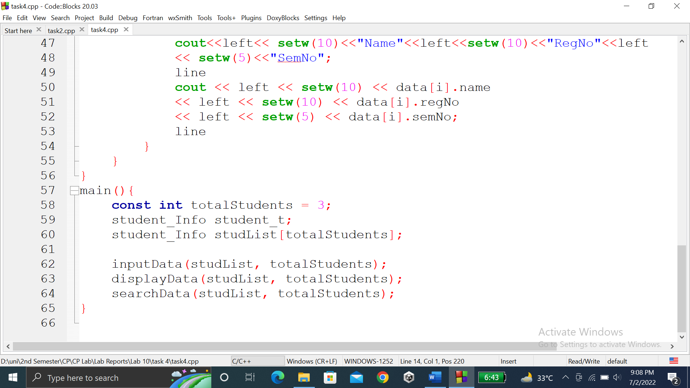

### **OUTPUT (COMPILATION, DEBUGGING & TESTING):**

Here is the screenshot of the output of above code.

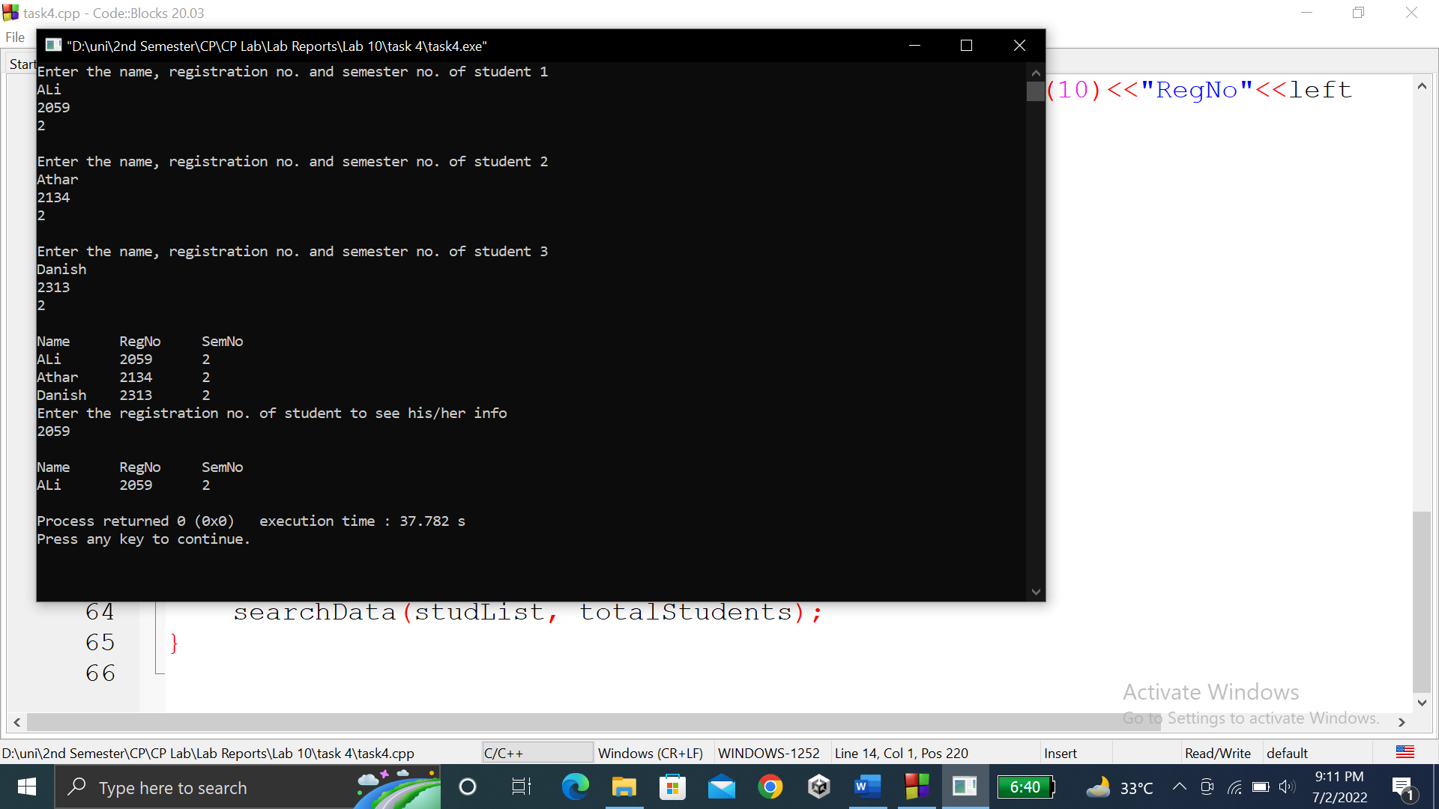

**TASK # 5:**

**Title:**

Make a C++ Program that will have a Class of your choosing………Your class must contain the following

**CODE SCREENSHOTS:**

Here are the screenshots of the code.

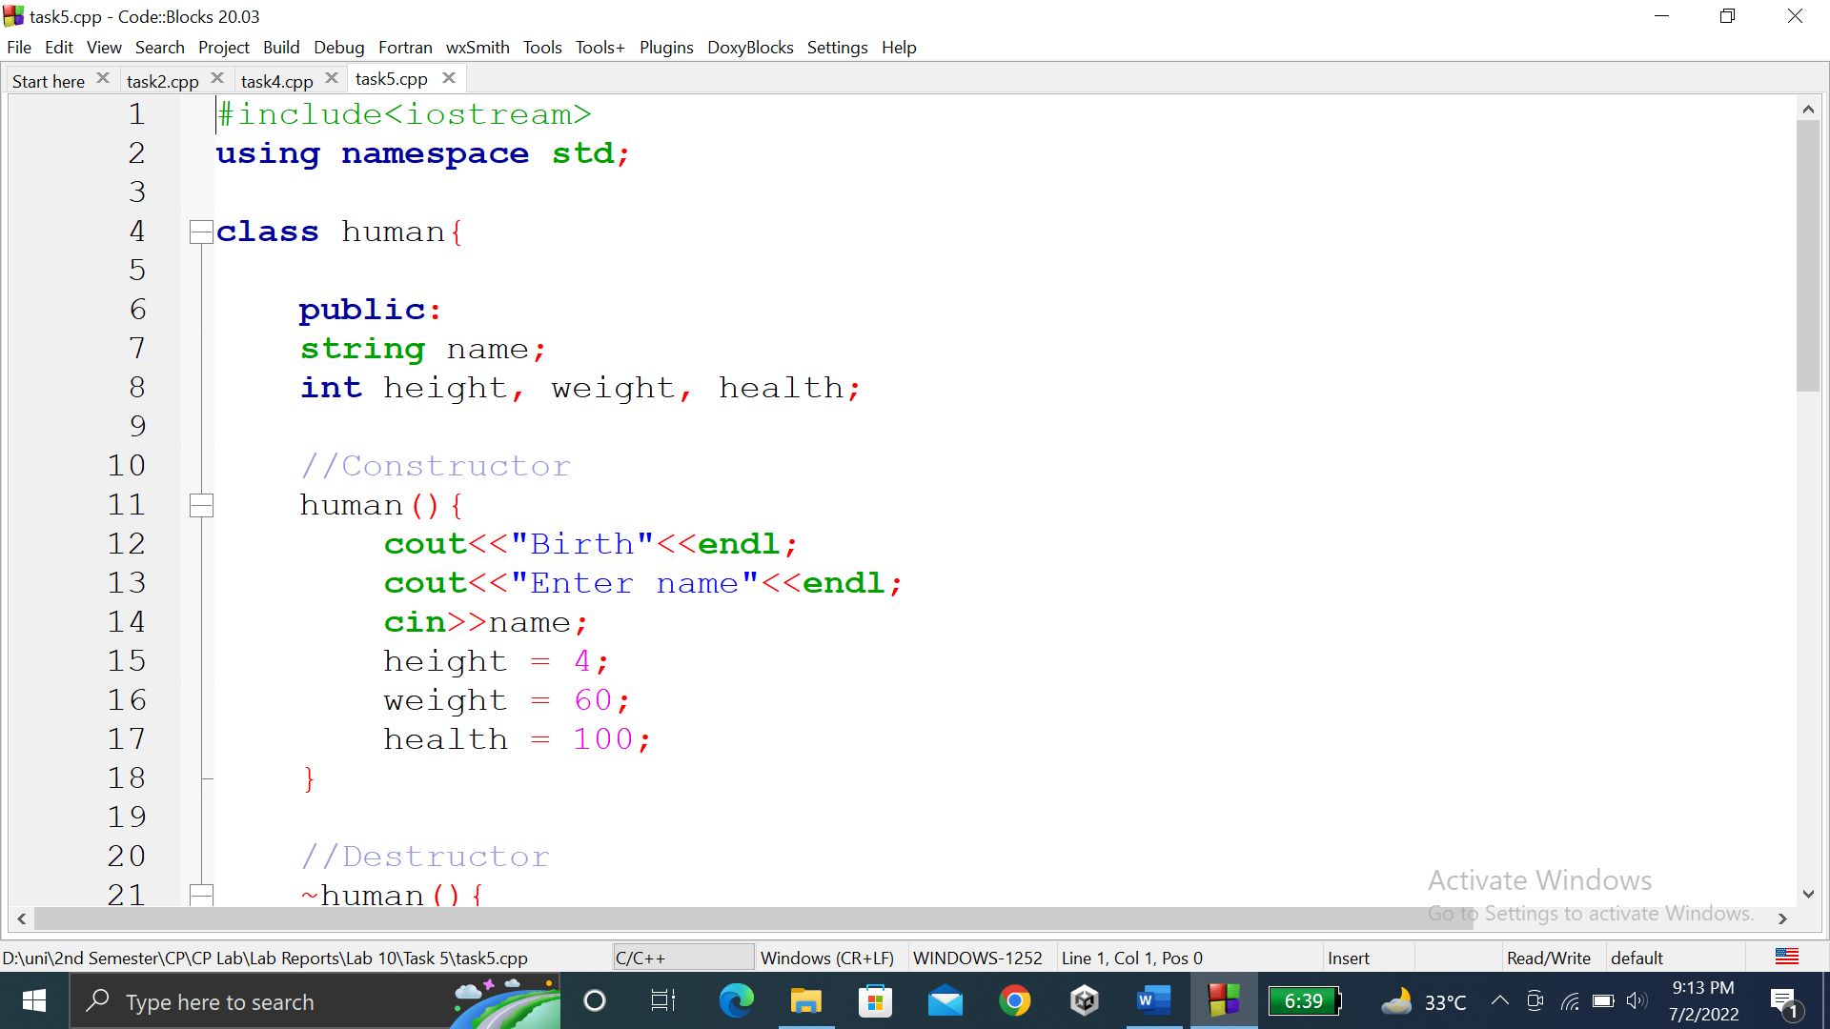

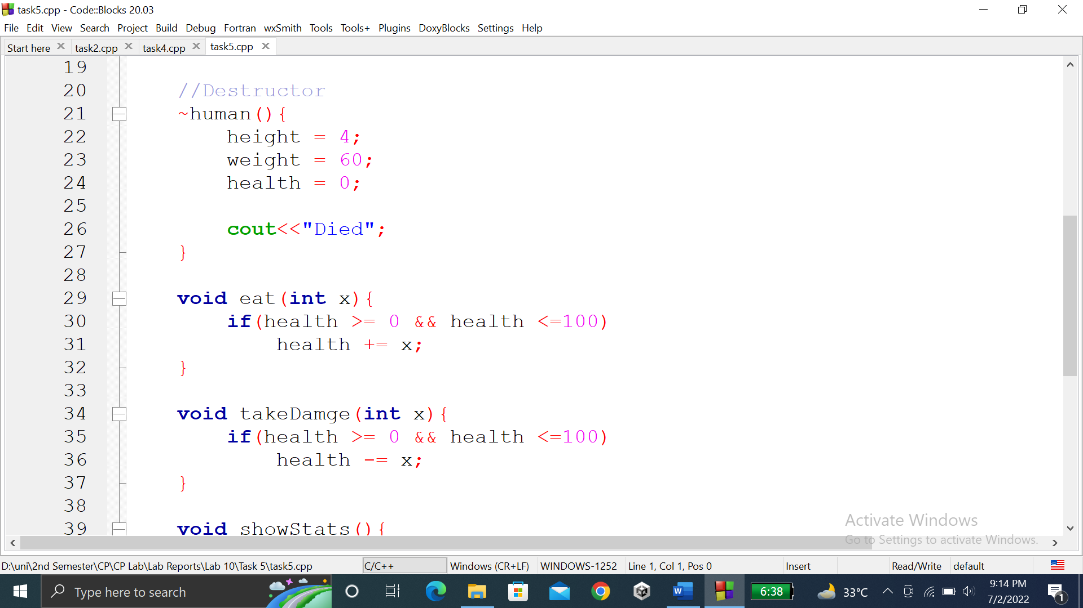

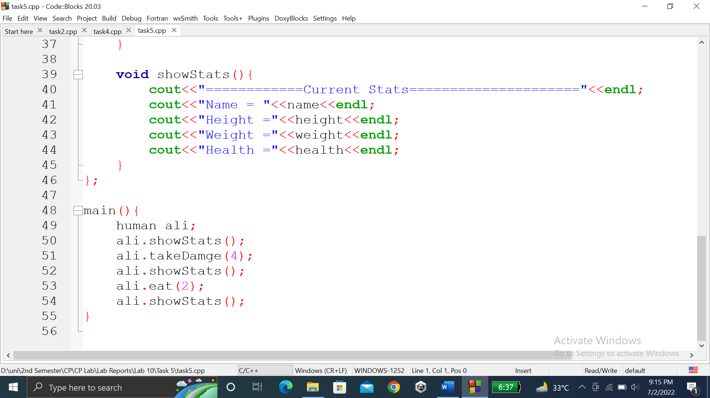

### **OUTPUT (COMPILATION, DEBUGGING & TESTING):**

Here is the screenshot of the output of above code.

